SIMATS ENGINEERING
ASSESSMENT TOOL 2

COURSE NAME: Database Management Systems
COURSE CODE: CSA05
NAME:P.Jessica Hephzbah
REG NO: 192511425

COURSE OUTCOME COVERED

CO1: Analyze DBMS architecture, different data models, schema types, and design ER/EER diagrams, relational schemas for case-based scenarios by identifying entities and relationships. (BL1, BL2)

Activity Tool : Concept Mapping (Medium)
Assessment Tool Weightage: 35%

Dr

QUESTIONS Total Marks: 50
Q.No | Question | Bloom's Level | Marks
1 | Construct a concept map linking the following terms: DBMS, Schema, Instance, Data Model, ER Diagram, Entity, Attribute, Relationship. | BL2 – Understand | 5
2 | Create a concept map for the three-level ANSI/SPARC architecture showing data independence at each level. | BL2 – Understand | 5
3 | Map the relationship between file-based systems and database systems, highlighting the problems solved by DBMS. | BL2 – Understand | 5
4 | Design a concept map for ER diagram components: entity, weak entity, attribute types, relationship types, and participation constraints. | BL2 – Understand | 5
5 | Construct a concept map comparing Hierarchical, Network, and Relational data models with their key properties. | BL2 – Understand | 5
6 | Develop a concept map for the EER model showing how it extends the basic ER model with generalization, specialization, and aggregation. | BL2 – Understand | 5
7 | Create a visual concept map for the DBMS software architecture, illustrating the flow from user request to data retrieval. | BL2 – Understand | 5
8 | Map the data models discussed in CO1 to real-world applications and explain the suitability of each model. | BL2 – Understand | 5
9 | Construct a concept map for schemas and instances, showing how they relate to physical and logical data independence. | BL2 – Understand | 5
10 | Design a concept map for the roles and responsibilities in a DBMS environment: DBA, End User, Application Developer. | BL1 – Remember | 5

Code of Conduct:

I ____________________ (Name / Reg No) certify that this submission is my original work and that I have adhered to the guidelines specified for this assessment.
I understand that any violation of academic integrity rules will result in disciplinary action.

Signature of the student:

RUBRICS FOR CALCULATION:

Criteria | Weightage | Level 4 (Exemplary) | Level 3 (Proficient) | Level 2 (Developing) | Level 1 (Beginning)
Concept Identification | 25% | Identifies all key concepts from literature accurately and comprehensively | Identifies most key concepts with minor omissions | Identifies limited concepts; some are irrelevant or missing | Fails to identify essential concepts
Linkages | 25% | Establishes clear, meaningful, and accurate relationships between concepts | Shows correct relationships with minor gaps | Relationships are weak, unclear, or partially incorrect | No meaningful relationships established
Organization | 20% | Concepts are well-structured hierarchically with logical flow and grouping | Mostly organized with minor structural issues | Some organization but lacks clear hierarchy | No logical organization or structure
Integration of Literature | 20% | Integrates multiple studies effectively to show connections and comparisons | Shows some integration of literature | Limited integration; mostly isolated concepts | No integration of literature evidence
Clarity | 10% | Concept map is clear, neat, visually structured, and easy to interpret | Generally clear with minor readability issues | Clarity is reduced; difficult to interpret in parts | Poorly presented and hard to understand

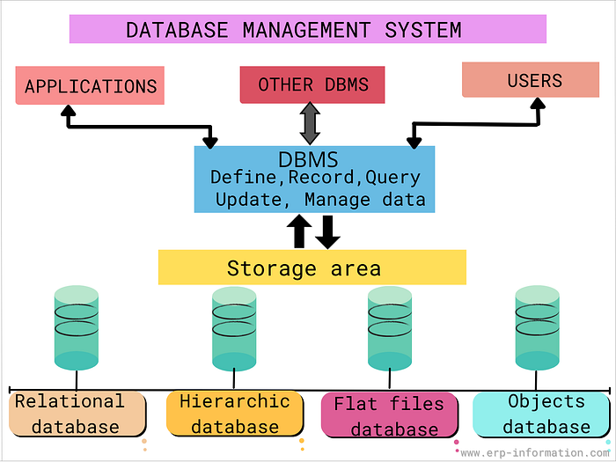

1)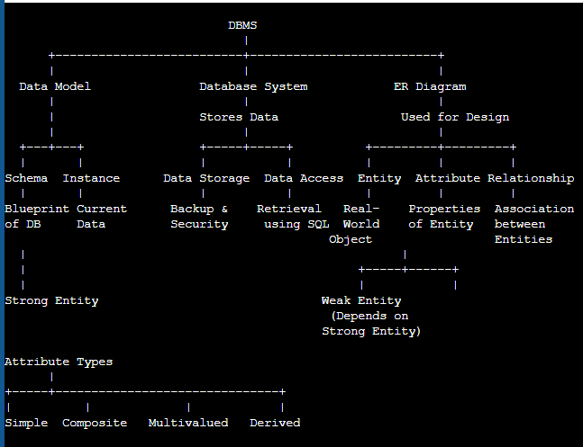

Explanation
- DBMS – Software used to store and manage databases.
- Data Model – Defines how data is organized.
- Schema – Logical structure (blueprint) of the database.
- Instance – Actual data stored at a particular time.
- ER Diagram – Graphical representation of the database.
- Entity – A real-world object.
- Attribute – Property of an entity.
- Relationship – Connection between entities.

2)
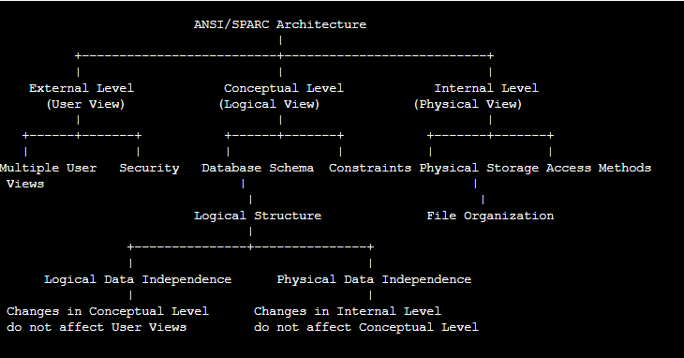
- Explaination:
- External Level – Different views for different users.
- Conceptual Level – Overall logical database design.
- Internal Level – Physical storage of data.
- Logical Data Independence – Changes in logical design do not affect users.
- Physical Data Independence – Changes in storage do not affect logical design.

3)
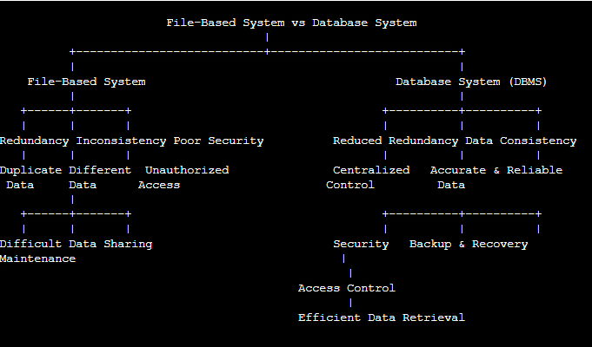

File-Based System
A File-Based System stores data in separate files. Each application maintains its own file, which often leads to duplicate data and management difficulties.
Problems of File-Based Systems:
- Data Redundancy: The same data is stored in multiple files.
- Data Inconsistency: Duplicate data may have different values in different files.
- Poor Security: Limited access control makes data vulnerable.
- Difficult Maintenance: Updating and managing multiple files is time-consuming.
- Limited Data Sharing: Sharing data between applications is difficult.

4)
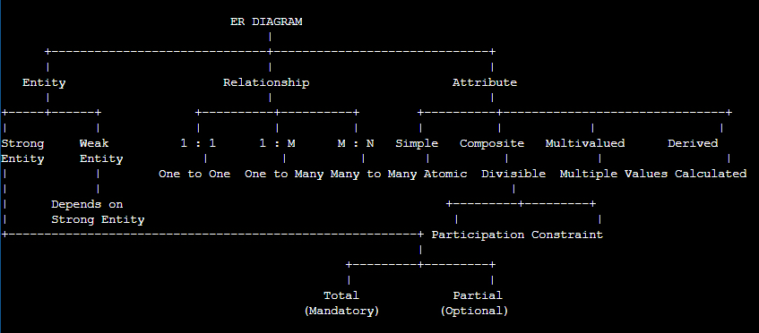

ER Diagram
An Entity-Relationship (ER) Diagram is a graphical representation of a database that shows entities, attributes, relationships, and constraints.

Entity
An Entity is a real-world object about which data is stored.
- Strong Entity: Exists independently and has its own primary key.
- Weak Entity: Depends on a strong entity for identification.

Relationship
A Relationship represents an association between two or more entities.
- 1:1 (One-to-One): One entity is related to only one entity.
- 1:M (One-to-Many): One entity is related to many entities.
- M:M (Many-to-Many): Many entities are related to many other entities.

5)
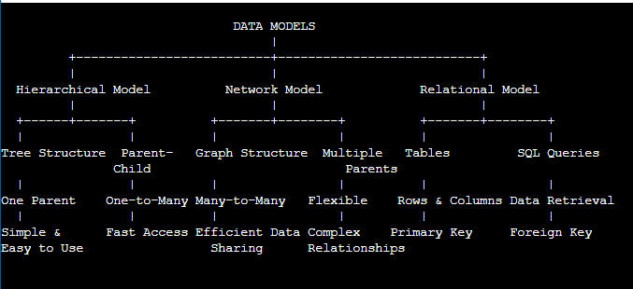

Data Models
A Data Model defines how data is organized, stored, and managed in a database. The three common database models are Hierarchical, Network, and Relational.

1. Hierarchical Model
The Hierarchical Model organizes data in a tree-like structure.
- Uses parent-child relationships.
- Each child has only one parent.
- Supports one-to-many (1:M) relationships.
- It is simple and provides fast data access.

2. Network Model
The Network Model organizes data in a graph structure.
- A child can have multiple parents.
- Supports many-to-many (M:N) relationships.
- Offers flexible data access and efficient data sharing.
- Suitable for complex relationships.

3. Relational Model
The Relational Model stores data in the form of tables consisting of rows and columns.
- Uses Primary Keys and Foreign Keys to establish relationships.
- Supports SQL for data manipulation and retrieval.

6)
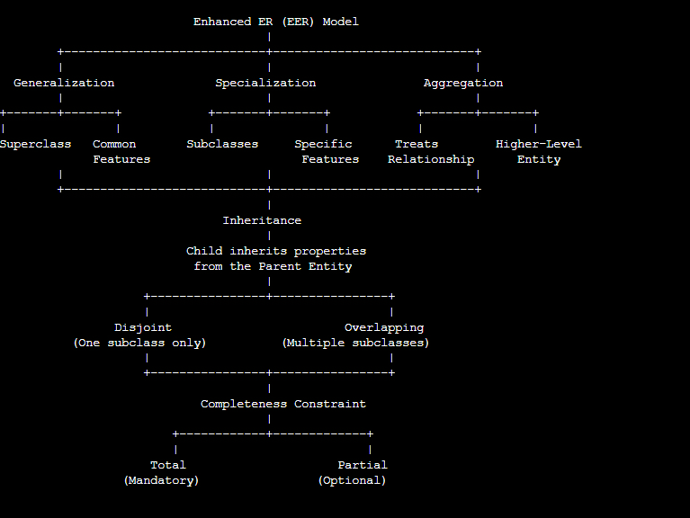

Enhanced Entity-Relationship (EER) Model
The Enhanced Entity-Relationship (EER) Model is an extension of the basic ER model used to represent complex database structures.
1. Generalization
- Combines lower-level entities into a superclass.
- Example: Car and Bike → Vehicle.
2. Specialization
- Divides a superclass into subclasses based on specific features.
- Example: Employee → Manager, Engineer.
3. Aggregation
- Treats a relationship as an entity to model complex relationships.
4. Inheritance
- Subclasses inherit the attributes and relationships of the superclass.

7)
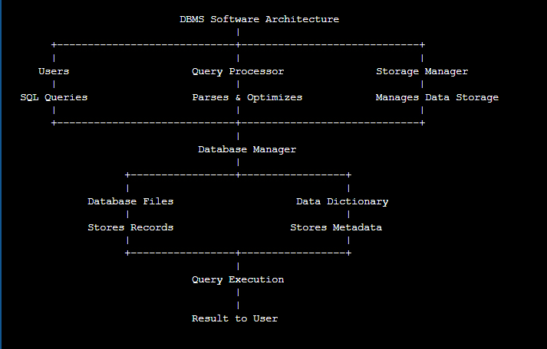

DBMS Software Architecture
The DBMS Software Architecture shows how a DBMS processes user requests and manages data efficiently.

1. Users
- Users interact with the database by submitting SQL queries.

2. Query Processor
- Interprets, validates, and optimizes SQL queries before execution.

3. Storage Manager
- Manages the storage, retrieval, and updating of data in the database.

4. Database Manager
- Coordinates communication between the query processor and storage manager.
- Controls database operations and transaction processing.

5. Database Files
- Store the actual data records permanently.

6. Data Dictionary
- Stores metadata such as table definitions, constraints, and schemas.

7. Query Execution
- Executes the processed query and retrieves the required data.

8. Result to User
- The requested information is returned to the user after successful execution.

9)
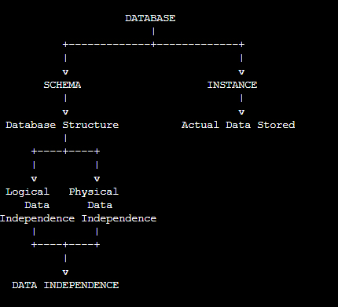

Explanation
- Schema: Defines the structure of the database, including tables, attributes, and relationships.
- Instance: Represents the actual data stored in the database at a specific point in time.
- Logical Data Independence: Allows changes to the logical schema without affecting application programs.
- Physical Data Independence: Allows changes to physical storage without affecting the logical schema.
- Data Independence: Improves flexibility, maintainability, and performance of the database.

10)
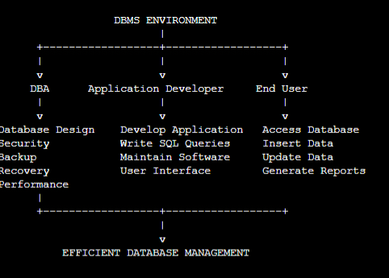

Explanation
- Database Administrator (DBA): Designs the database, manages security, performs backup and recovery, and optimizes performance.
- Application Developer: Develops database applications, writes SQL queries, and maintains the software.
- End User: Accesses the database to retrieve, insert, update, and manage data through the application.
- DBMS Environment: All three roles work together to ensure efficient, secure, and reliable database management.

